New directions of research and development in the field of nanotechnology for the creation and application of inorganic composite materials
Part II

Pavel Kudryavtsev, Nikolai Kudryavtsev, Alex Trossman
Polymate Ltd – Israel Nanotechnology Research Center, Israel,
Abstract. In the paper, we give a brief overview of the main developments made personally and under the direct supervision of the professor, academician RANS andIAELPS P. Kudryavtsev. These developments are devoted to the use of sol-gel processes in various branches of science and technology. Using this process, new composite heat-resistant materials, highly disperse materials and thin filmswere created. These developments have made it possible to create new efficient catalysts and highly selective inorganic ion-exchange materials. Based on inorganic ion-exchange materials, a technology was developed to extract lithium from natural brines, which are poor in lithium content. On the basis of sol-gel technology, new composite matrix-isolated flocculants-coagulants were created. These reagents are designed for the treatment of natural and wastewater in order to remove impurities of oil products and heavy metals.
Keywords: Nanomaterials, Sol-Gel Technology, Nanostructured Materials, Composite Materials, Highly Dispersed Materials, Thin Films, Catalysts, Highly Selective Inorganic Ion Exchangers, Extraction of Lithium, Composite Flocculants-Coagulants.

Continued. The beginning of the work published under the same title in the previous issue of the magazine “Inženernyj vestnik Dona (Rus)” N 3, 2017.

Inorganic Ion-Exchange Materials
A large group of materials obtained by sol-gel technology is inorganic ion exchangers. Kudryavtsev P.G. and his colleagues have developed a technology for production and industrial tests were conducted wide range of inorganic ion-exchange materials [10-35,41-45]. Inorganic ion exchangers, unlike their organic counterparts, usually have a rigid structure and do not undergo significant changes in the process of ion exchange. Rigid structure leads to a specific and unusual selectivity. Selectivity of inorganic ion exchangers can be considered from the point of view of ion sieve effect, of steric factors, ion dimensional preferences, effect of entropy and ion memory.Considering inorganic ion exchangers as a matrix (polyanionic frame crystalline or quasi-crystalline lattice) with cations, distributed in the matrix, then the classification of the sorption processes can be represented as follows (table. 2).
One such class of inorganic ion exchangers (sorbents) is hydrous oxides of metals. They have such a variety of structural types that allow you to modify them widely, creating highly selective ion-exchange materials to specific types of ions. Ion exchange in hydrous oxides proceeds with the participation of functional OH-groups with quite different acid-basic properties. These properties of these materials have been investigated by the method of potentiometric titration.

Table 2.
Sorption processes types in ion-exchange inorganic materials.
Process name | The nature of the exchange of ions between the solution and the sorbent | The nature of changes in the phase sorbent
Ion exchange | Equivalent exchange of ions | The formation of solid solutions of replacement
Molecular sorption | Absorption sorbent equivalent quantities of anions and cations salt | The formation of solid solutions of implementation
The exchange of electrons | The uptake and release of ions from the sorbent associated with recovering or oxidation of the sorbent | The formation of solid solutions implementation or subtraction. The change in charge of the matrix of the sorbent
Heterogeneous ion-exchange reaction | Equivalent exchange of ions | Phase transformation
Chelate adsorption | The absorption of ions by sorbent with the formation of coordination bonds between ion and active centers of the sorbent | The emergence of new supramolecular compounds of the type of intercalated or complexes of the type of guest-host
In excess of stoichiometric absorption | Superequivalent exchange of ions | The emergence of polymer chains and the formation of new phases in the pores of the sorbent

Titration results indicate that niobium hydrous pentoxide (NHP) and titanium hydrous oxide (THO) are mainly cation-exchange properties, and aluminum hydrous oxide (AHO) - mainly anion-exchange properties (Fig. 3). All investigated materials are polyfunctional exchangers, containing in the structure of OH-groups with different values pK. For such inorganic ion-exchange materials is characterized by the appearance of sorption memory effects and ion sieve effects.

ssssst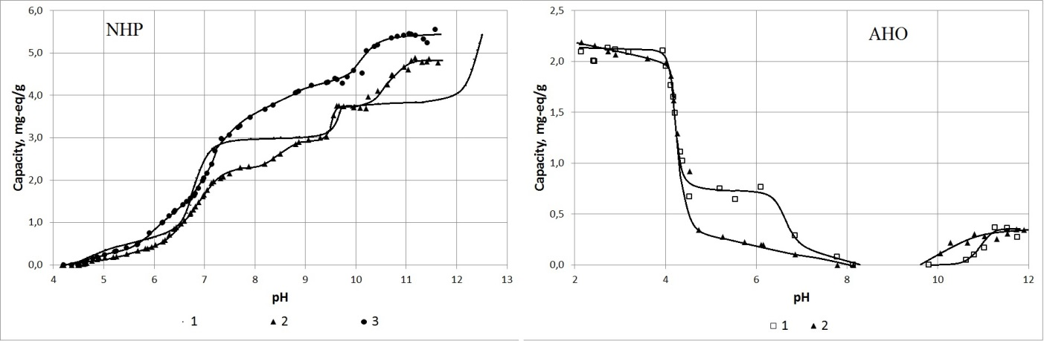
Figure 3. Potentiometric titration curves of niobium hydrated pentoxide (NHP) and hydrated alumina (AHO).
NHP: 1 - initial NHP; 2 - NHP with the addition of Fe(III); 3 - NHP with additives Mo(VI);
AHO: 1 - received by acid hydrolysis; 2 -received by alkaline hydrolysis.

One of the most promising groups of inorganic sorbents is transition metals ferrocyanides. Ferrocyanides transition metals found active use for removal of heavy alkaline elements from complex water-salt systems. The structure and sorption properties of transition metals ferrocyanides are closely related. According to modern concepts, ferrocyanides composition M^{I}_{4-2x}M^{II}_{x}Fe(CN)₆ are three-dimensional polymers with bridge links Fe─С≡N─МII. In polymer frame lattice consisting of an equal number of ions of Fe(CN)₆⁴⁻ and M²⁺, there are a cubic cavity, in which are placed excessive atoms of transition metal and alkali element (Fig.4).
This ferrocyanide has a composition:M^{I}_{4-2x}M^{II}_{x}Fe(CN)₆. This structure provides most of its affinity for heavy ions of alkaline metals - Rb and Cs.

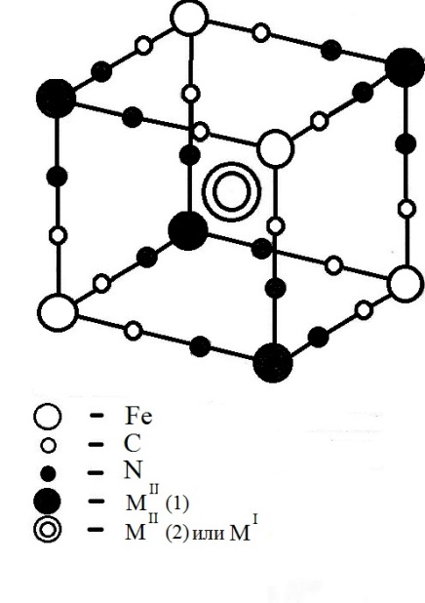

Figure 4. The structure of the 1/8 unit cell of the transition metal ferrocyanide.

This fact is confirmed by the fact that the logarithm of the constants of ion exchange for a pair of ions on the transition metal ferrocyanides grows linearly with the increase of the difference of the polarizabilities of ions between a given pair (Fig. 5). Transition metals ferrocyanides are also reversible oxidation-reduction properties, which allow desorption of absorbed ions of metals by oxidation matrix sorbent (Fig. 6).
Very important factor is the relationship between the structural changes in the phase sorbents and sorption characteristics. This can be achieved high efficiency of sorption processes with independent phase sorbents and sorption products. Such processes are called heterogeneous exchange reaction. On their basis has created a whole range of inorganic sorbents with exclusively selectivity to ions of transition metals. The existence of two phases - sorbent and the main salt - there is, for example, when interacting systems Cd(OH)₂-CdSO₄ and Cd(OH)₂-CdCl₂.

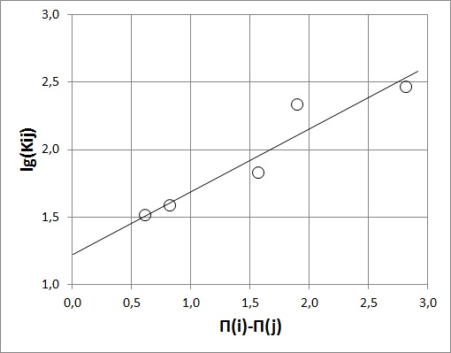
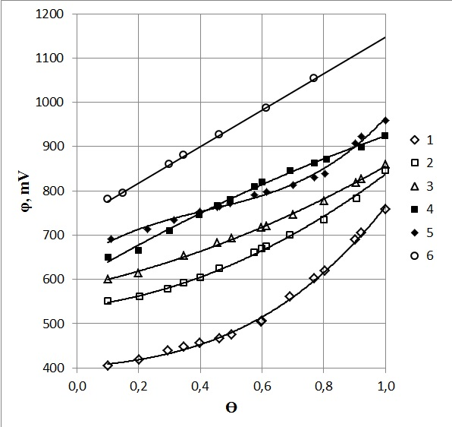
Figure 5. Dependence of $\lg\left(K_{ij}\right)$ on the difference of polarizabilities of some ions pairs in ion-exchange sorption on the nickel ferrocyanide.
Figure 6. The dependence of the redox potential (φ, mV) on the part of the oxidized form (ϴ) for electron-ion-exchanger based on mixed transition metal the ferrocyanides.
1 – Na_{1,0}Ni_{1,5}X;
2 – K_{1,0}Ni_{1,5}X;
3 – K_{1,22}Ni_{1,39}X;
4 – Rb_{1,24}Ni_{1,38}X;
5 – K_{0,60}Cs_{0,96}Ni_{1,22}X;
6 – Cs_{1,42}Ni_{1,29}X
(где X – [Fe(CN)₆]⁴⁻).
The cadmium hydroxide acts as a sorbent and it has sorbingCdSO₄ and CdCl₂ from the solution. As a result of this interaction, gives the corresponding basic salt (Fig. 7).

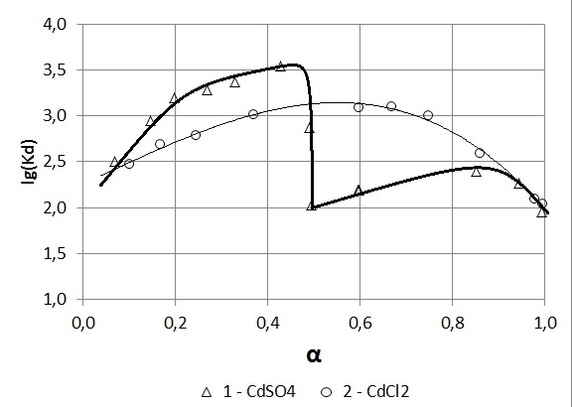
Figure 7. The dependence of the distribution coefficient (K_{d}) on the degree of transformation (α), describing the interaction Cd(OH)₂ with CdSO₄ (1) and CdCl₂ (2).

Highly Selective Composite Ion Exchange Materials for the Extraction of Rare and Trace Elements from the Natural and Technological Solutions Having a Complex Composition
The development of modern high-tech production puts the task of creating new and improving existing technological schemes of processing of natural raw materials and industrial waste in order to extract the rare, radioactive and trace chemical elements. One of the most promising methods for solving this problem is to use sorption and ion exchange methods. At the same time are put forward very rigid requirements to used sorbents. They can be achieved only using inorganic nanocomposite materials. We already synthesized inorganic sorbents with certain specific properties. Being decided now problem of the development of management techniques, the process of their synthesis in order to obtain a wide variety of sorbents that meet predetermined requirements of modern technologies.
The aim of this work is the development of technology of production and application, functional nanocomposite materials, which are highly selective sorption and ion exchange materials for the extraction of rare, trace, and radioactive elements from natural and technological highly concentrated solutions. In particular, the extraction of lithium and rubidium from the Dead Sea brines [8].
Inorganic ion exchangers, compared with the organic ion exchangers are more resistant to high temperatures and ionizing radiation. We have synthesized new types of ion exchangers having a greater resistance than the previously known aluminosilicate ion exchangers; selectivity of some of them with respect to certain ions was significantly higher [4]. In addition, important practical application of inorganic ion exchangers, the study of their properties is of independent scientific interest. The selectivity of inorganic ion exchangers, compared with organic ion exchange resins has a completely different nature and differs by orders of magnitude.
Below are the test results of cation exchangers, such as ISN, on extraction of lithium from real natural brines.
ISN-1
$$K_{ij}=\frac{K_{d}^{i}}{K_{d}^{j}}=\frac{ε_{i}c_{j}}{c_{i}ε_{j}}$$
$$ε_{Li}=1,30±0,02 \left[{mg-eq}/g\right]$$
$$ε_{Na}=0,16±0,01 \left[{mg-eq}/g\right]$$
$$K_{Li,Na}=(1,20±0,09)∙{10}^{4}$$
ISNZ-1
$$ε_{Li}=2,53±0,08 \left[{mg-eq}/g\right]$$
$$ε_{Na}=0,37±0,04 \left[{mg-eq}/g\right]$$
$$K_{Li,Na}=(1,32±0,08)∙{10}^{4}$$

Inorganic ion exchangers, unlike their organic analogs typically have rigid structures and do not experience significant changes in the ion exchange process, and they are resistant to high temperatures and ionizing radiation. Their rigid structure leads to specific and extraordinary selectivity. Selectivity of inorganic ion exchangers can be considered from the viewpoint of ion sieve effect, steric factors, ion size preferences entropy effect, and ion storage. Control structure of such a composite is carried out on subnanometer level, so you can call such materials as sub-nanocomposites, or picocomposites. In this regard, the inorganic sorbents can also be used for the preparation of pure solutions of the corresponding salts of isotopes of elements, and for purification of contaminated water and to provide the required level of the radiation and chemical safety. They can be used for the extraction of rare and trace elements of natural and industrial solutions with high salt background.
For example, based on these sorbents, a technology can be developed to extract lithium and rubidium from the Dead Sea water. This technology can be realized simultaneously with the extraction of magnesium and bromine.

Extraction of Lithium Using Highly Selective Inorganic Ion Exchangers
Currently, to extract lithium from its natural minerals, they are decomposed by the action of sulfuric acid (acid method), or sintered with CaO or CaCO₃ (alkali method), or treated with potassium sulfate K₂SO₄ (salt method), and then leached with water. When a lithium raw material is comprised of natural brines, it is extracted by a halurgical method based on the difference in solubility’s of sodium and lithium chlorides in concentrated solutions and in the presence of other metal salts. Brines poor in lithium require the use of a lithium sorption extraction method with the use of selective sorbents. Since the lithium-rich brines can be quickly exhausted, an agenda will be a question of lithium extraction from relatively lithium-poor sources of raw materials.
In any case, a preprocessing produces a concentrate solution of lithium salts. The resulting solution is used for recovery of poorly soluble lithium carbonate Li₂CO₃, which is then converted into chloride LiCl. Melt electrolysis of lithium chloride is carried out in admixture with KCl or BaCl₂ (these salts are used to lower the melting temperature of the electrolyte mixture):

$$2LiCl → 2Li + {Cl}_{2}↑$$

Further, the resulting lithium metal is purified by vacuum distillation at a temperature of about 550°C.
Lithium can be leach out of the rocks, and the most common raw source of this element is natural waters. The content of lithium in seawater averages 1.5 to 10⁻⁴g/l. From a technological point of view such concentration is low. Much more promising are some lake brines. The maximum known lithium concentration of 56 mg/lis observed in chloride-type lake waters. Accordingly, lakes are considered as real sources of a lithium raw material.
It has been shown that a content of lithium in brines can be concentrated by natural evaporation. Experiments made still in the USSR confirmed increasing the lithium concentration in the brine during its evaporation from 2.1 to 32.5 mg/l, but the total mineralization of brine in this case was increases from 280 to 582 g/l.
A study has been conducted regarding a possibility of extracting lithium from free petroleum waters of Dagestan (in the area of South Sukhokumsk). A mixture of free saline waters had the following composition (g/l): NaCl - 75,5; KCl - 15.8; CaCl₂ - 20.3; MgCl₂– 2.20; SrCl₂– 1.22; and LiCl– 0.52. It was planned to carry out complex processing of these raw materials. However, these studies were discontinued in the early 90-ies.
Schemes of the existing industrial complexes for processing lithium-containing brines are oriented on Li-rich sources (with Li content in the range of 300 to 500 mg/l), and are based mainly on evaporation and sequential crystallization of different compounds [34, 38]. The sorption methods appear to be most promising for the brines with poor content of rare elements [39,40]. Separation of lithium from solutions in the form of carbonate is effective when its content in the solution is not less than 20 to 25 g/l. For brines with the lithium concentration of 40 mg/l this corresponds to a concentration degree of 500. On the other hand, ion exchange processes developed for the above purpose provide not only a required degree of concentration but also specified production efficiency.
The problem of extracting lithium from salt brines is largely connected with their molar ratio of ion Na⁺ to Li⁺, i.e., the value of Na/Li. Sodium is one of the elements which is the closest to lithium in its chemical properties and which, as a rule, also has the highest content in natural waters. In some classes of chloride brines, the Na/Li ratio can reach 93000. Under such conditions, conventional methods based on the precipitation of sparingly soluble compounds of lithium, such as phosphates, are not effective. Promising are only sorbents, which are highly selective to Li⁺ ions.
Inorganic sorbents such as ISM-1 have been developed for the extraction of lithium from highly mineralized natural brines. The basis of these sorbents is manganese dioxide. Under the effect of thermal recrystallization the manganese dioxide acquires a structure in which the cation-exchange positions strictly correspond to Li⁺ ions, while access of Na⁺ ions inside the crystal grains is limited due to the "ion-sieve" effect. The sorption-desorption processes are accompanied only by H⁺$↔$ Li⁺ type exchange. Main features of the ICM-1 sorbent are partition coefficients for the H⁺ - Li⁺ ion pair, which reach (1 ÷ 5)·10⁴ .The exchange capacity of 4 ÷ 5 mol Li⁺/kg (full); and 1.0 ÷ 2.0 mol Li⁺/kg (working capacity in solutions of complex salt compositions). The residual concentration of Li⁺ ions in the filtrate after sorption in the range of 0.1 to 0.3 mg/dm³.
The modified sorbent ISMA-1 was tested in the process of lithium extraction from the underground solution of iodine-bromide production (Perm, Russia). The solution had the following composition (g/dm³): NaCl - 189; CaCl₂ - 56.05; MgCl₂ – 14.9; KCl - 2.47; NaBr – 1.12; SrCl₂ – 0.42; Na₂B₄O₇ – 0.12; KI – 0.02; Li⁺ - 11·10⁻³, pH 8.2. Sorption was performed prior to breakthrough of Li⁺ ions to the filtrate - 0.9 mg/dm³. Test results: sorption capacity was 17 g Li⁺/kg; the degree of lithium extraction was 91.5%. The author took active part in the development of technology for these and other similar sorbents, as well as in the test of their properties in case of real industrial and natural solutions [41-45].

New Composite Matrix-Isolated Flocculants-Coagulants
Aluminum-silicon flocculant-coagulant ASFC is one of the few binary compositions comprising only inorganic components: coagulant – aluminum sulfate and flocculant anionic – active silicic acid. The action of the ASFC based on the fact that as a result of interaction of primary components ASFC – coagulant compounds of aluminum and flocculant active silicic acids form complex compounds with a higher flocculation ability of nanosized zeolite like structure with well-developed sorption surface. There is a synergistic effect - increasing the efficiency of the impact resulting from integration of individual processes into a single system. The mechanism of water treatment is realized by volumetric adsorption of pollutants on self-organizing of aluminosilicate complexes.
Sulfuric acid solution ASFC was described as a reagent for the purification of water [46]. The significant disadvantages of the aqueous solutions of ASFC are certain difficulties arising from the carriage, and the limited duration of its use (within a few days the ASFC solution turns into a gel and loses the properties of flocculant-coagulant). For this reason and because of economic inexpediency of transportation solution application aluminum-silicon flocculant-coagulant is concentrated at the sites of production. This factor hindered the practical use of the ASFC practice in industrial wastewater treatment. So important is the search for new reagents of this type and conditions for their stabilization. For comparative characteristics, we obtained the liquid aluminum-silicon flocculant-coagulant from nepheline concentrate by decomposition of sulfuric acid [47], hereinafter referred to as ASFC-1, and a new aluminum-silicon flocculant-coagulant ASFC-2 - white substance in pellets allocated in certain technological conditions of the sulfuric acid solution of flocculant-coagulant ASFC-1.
Our task was to develop a method of obtaining aluminum-silicon flocculant-coagulant is in the form of a crystalline product, which has a higher stability, so the shelf life of the product should be not less than 6 months. It needs to be easy to manufacture and cost-effective transport and to have a higher content of active component. So the content of aluminum, calculated as aluminum oxide — 6.8÷7.9 % of silicon, calculated as silicon oxide — 10.2÷12.0%. Must be efficient and simple in use for wastewater treatment
The task was solved by using in the processing of aluminum (nepheline) of the raw material with sulfuric acid, separation of the liquid phase from the solid and liquid phase dehydration [48]. The processing carried out with concentrated sulfuric acid under conditions allowing obtaining concentrated 20÷30 %, aqueous solution of flocculant-coagulant. Dehydration of resulting solution carried out at a temperature below the boiling point of water, the method of evaporation under vacuum or high velocity dispersion in high-temperature gas stream of the coolant. The product was dried and separated from the coolant temperature lower than the boiling point of water.
The authors have developed a method of producing aluminum-silicon flocculant-coagulant as a crystalline product that has higher stability. Shelf life of the developed product is more than 6 months. Furthermore, it is effective and simple to use, easy to manufacture and economical transportation has a higher content of active ingredient: aluminum content, expressed as aluminum oxide – 6.8÷12.7 %, the silicon content, expressed as silicon oxide – 10.2÷18.6 % [48-51].
The basis of this method of synthesis, which based on the principles underlying the known method of matrix isolation, was developed at the end of the last century. Matrix isolation method allows you to freeze and study of reactive particles with a short lifetime in an inert solid matrix. As is known, the intermolecular interaction is most pronounced in the case of chemically reactive species such as most atoms, free radicals and molecules that are Monomeric only at high temperatures can be investigated in the gas phase only at low concentrations. However, even in such extreme conditions, some particles are so reactive that exist for a very short time after formation; therefore, the study of their molecular properties is very difficult.
Matrix isolation method has arisen as attempt to overcome the above difficulties in the study of reactive molecules. It consists of freezing of the studied molecules in a rigid environment (the matrix) at low temperatures. The rigidity of the matrix prevents diffusion of active molecules, i.e., hampers their interaction with other similar particles. In turn, the inertia matrix substances are necessary to prevent the interaction of active particles with the matrix [52,53]. This situation can be seen when you receive aluminum-silicon flocculant-coagulant.
The use of such technological methods allowed «freezing» and isolating in the matrix of the solid phase components of the flocculant-coagulant. In this method acidic salt of aluminum sulfate and active silicic acid are in nanosized state. Quick active components in the solid state can dramatically reduce the rate of diffusion processes and thus to maintain the activity of the material.
The resulting material was named ASFC-2. It contains: aluminum (in terms aluminum oxide) is not less than 11.1÷12.7 wt. %; silicon (in terms of silicon oxide) is not less than 16.3÷18.6 wt. %. When dissolved in water to form a 1% solution, its pH was 3.5.
ASFC-1 and ASFC-2 have been testing for water purification on model samples and on samples of wastewaters of oil refineries. For this purpose, the water samples were added different concentrations of ASFC and samples were bubbled for a certain period.Quality indicators were controlled by standard methods.
Tests were carried out with the addition of ASFC-1 in the form of a solution and ASFC-2 in the form of a solution or in a powdery state thereby enabling its benefits.
To compare the effectiveness ASFC-1 and ASFC-2 were tested the effect of flocculants-coagulants in the following indicators: turbidity, chromaticity, mass concentration of iron (III), chromium (III) phosphate ions and the concentration of oil in water. The definition of the indicator of turbidity was carried outphotometrically by comparing samples of the investigated water with standard suspensions of kaolin. The results of the measurements are presented in figures 8.

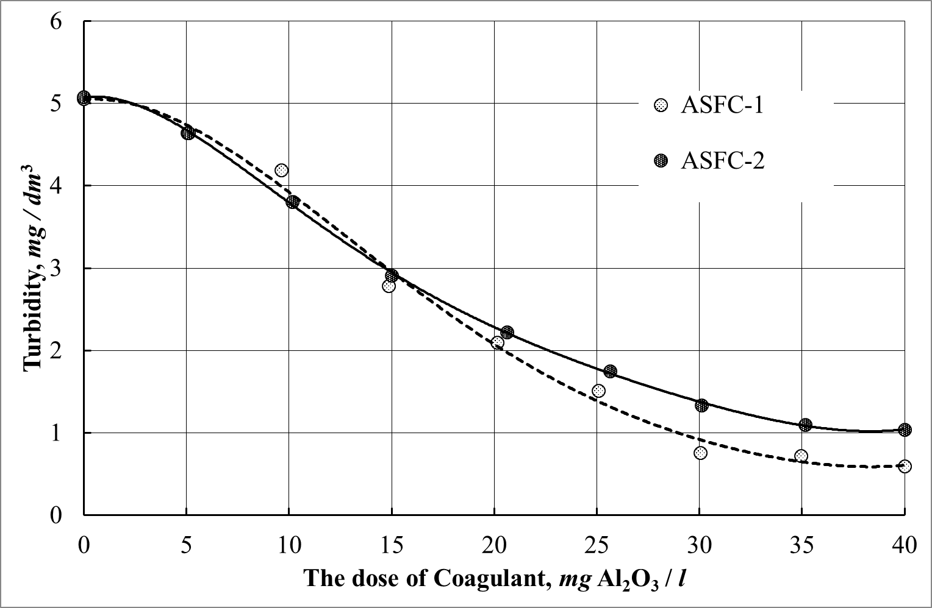
Figure 8. The dependence of turbidity of treated water and the coagulant dosage

CONCLUSION

In this paper, we present a brief overview of the main research and development that were done personally and under the direct supervision of the professor, academician RANS and IAELPS P. Kudryavtsev. The main idea of these developments is the use of sol-gel processes for the recovery of a wide range of new composite materials used in various branches of science and technology. This method is one of the directions of nanotechnology. Using this process, new composite heat-resistant materials, highly disperse materials and thin films. The carried out researches and developments have allowed creating new effective catalysts and highly selective inorganic ion-exchange materials. Based on inorganic ion-exchange materials, a technology was developed to extract lithium from poor in composition natural brines. The use of sol-gel technology was the main technological method that allowed creating new composite matrix-isolated flocculants-coagulants for reagent purification of natural and wastewater from impurities of oil products and heavy metals.The presented works open a new direction in nanotechnology of various functional materials and technological methods for solving complex problems, which are facing modern technology.

References
1. Figovsky O.L., Kudryavtsev P.G. Advanced Nanomaterials based on Soluble Silicates, Journal "Scientific Israel - Technological Advantages", Vol.16, no.3, (2014).
2. Kudryavtsev P., Figovsky O. Nanomaterials based on soluble silicates, ISBN 978-3-659-63556-4, LAP Lambert Academic Publishing, 2014, 241 p.
3. Kudryavtsev P., Figovsky O. Nanocomposite Organomineral Hybrid Materials, Journal "Scientific Israel - Technological Advantages", Vol.17, no.3, 2015, pp.7-60, ISSN: 1565-1533.
4. Kudryavtsev P. Alkoxides of chemical elements - Promising class of chemical compounds which are raw materials for HI-TECH industries, Journal "Scientific Israel - Technological Advantages", Vol.16, no.2, 2014.
5. Kudryavtsev P., Figovsky O. The sol-gel technology of porous composites, LAP Lambert Academic Publishing, ISBN 978-3-659-78529-0, 466 p.
6. Kudryavtsev P.G., Figovsky O.L. Method of Producing Soluble Silicates with Organic Cations. US Patent. No: 9,695,111 B2, Receipt Date: 22-SEP-2015.
7. Brinker C. J., Scherer G.W. Sol-Gel Science. The Physics and Chemistry of Sol-Gel Processing. San Diego: Academic Press, (1990).
8. MaksimovA.I., Moshnikov V.A., TairovU.M., ShilovaO.A. Fundamentals of Sol-gel technology of nanocomposites, SPb.: SPbGETU "LETI", (2007).
9. Пахомов Н.А. Научные основы приготовления катализаторов: введение в теорию и практику, Рос. акад. наук, Сиб. отд-ние, Ин-т катализа им. Г.К. Борескова. — Новосибирск: Изд-во СО РАН, 2011. 262 с. ISBN 978-5-7692-1185-0.
10. Kudryavtsev P.G., Onorin S.A., Volkhin V.V., IzvestiyaVUZ. Non-ferrous metallurgy, 3, (1977), 50.
11. Kudryavtsev P.G., Onorin S.A., Inorganic ion exchangers (synthesis, structure, properties), 212, (1977), 105.
12. Volkhin V.V., Leontieva G.V., Onorin S.A., Khodyashev N.B., Kudryavtsev P.G, ShvetsovaT.I., Chemistry and technology of inorganic sorbents, Perm, RF, (1980), 67.
13. Kudryavtsev P.G., Onorin S.A., Volkhin V.V., The method of obtaining of inorganic anion-exchanger, A.S. USSR № 1274763, (1985).
14. Kudryavtsev P.G., Onorin S.A., Volkhin V.V., Solid state chemistry, Sverdlovsk, (1983), 67.
15. Kudryavtsev P.G., Onorin S.A., Volkhin V.V., The method of obtaining of inorganic sorbents for extraction of lithium from solutions, A.S. USSR № 1160627, (1983).
16. Kudryavtsev P.G., Onorin S.A., Volkhin V.V., The method of obtaining of selective for lithium inorganic sorbent, ASSTR № 1203739, (1984).
17. Kudryavtsev P.G., Onorin S.A., Volkhin V.V., The method of obtaining of inorganic anion-exchanger, A.S. USSR № 1125043, (1983).
18. Kudryavtsev P.G., Onorin S.A., Volkhin V.V., The method of obtaining of inorganic sorbent selective for lithium, A.S. USSR № 1256274, (1985).
19. Kudryavtsev P.G., Onorin S.A., Volkhin V.V., The method of obtaining of inorganic anion-exchanger, A.S. USSR № 1189497, (1984).
20. Kudryavtsev P.G., Journal of physical chemistry, 61, 3, (1987), 848.
21. Kudryavtsev P.G., Onorin S.A., The method of obtaining of inorganic anion-exchanger AAT-1, A.S. USSR № 1435280, (1987).
22. Kudryavtsev P.G., Onorin S.A., Volkhin V.V., The method of obtaining of inorganic anion-exchanger, A.S. USSR № 1435281, (1987).
23. Kudryavtsev P.G., Onorin S.A., Volkhin V.V., Chemistry and technology of inorganic sorbents, interuniversity collection of scientific papers, PPI, Perm, (1989), 140.
24. Kudryavtsev P.G., Onorin S.A., Volkhin V.V., IzvestiyaVUZ. Nonferrous metallurgy, 2, (1990), 21.
25. Kudryavtsev P.G., Onorin S.A., Volkhin V.V., IzvestiyaVUZ. Nonferrous metallurgy, 3, (1990), 26.
26. Kudryavtsev P.G., Volkhin V.V., The Sol-gel processes of obtaining of inorganic materials, Perm, (1991), 3
27. Kudryavtsev P.G., Onorin S.A., Volkhin V.V., Izvestiya AN SSSR ser. Inorganic materials, 27, 7, (1991), 1479.
28. Volkhin V.V., Leontieva G.V., Onorin S.A., Izvestiya AN SSSR ser. Inorganic materials, 9, 6, (1973), 1041.
28. Zilberman M.V., Volkhin V.V., J. structural chemistry, 12, (1971), 649.
30. Volkhin V.V., ShulgaE.A., Zilberman M.V., Izvestiya AN SSSR ser. Inorganic materials, 7, (1971), 77.
31. Volkhin V.V., Kolesova S.A., Zilberman M.V., Onorin S.A., J. inorganic chemistry, 16, (1971), 1611.
32. KalyuzhnyA.V., Volkhin V.V., Zilberman M.V., Kolesova S.A., Journal Of Applied Chemistry, 50, (1977), 201.
33. Volkhin V.V., Zilberman M.V., Kolesova S.A., PykhtinaL.I., Tetenov V.V., KalyuzhnyA.V., Journal Of Applied Chemistry, 49, (1976), 1728.
34. Kalinin N.F., Volkhin V.V., Zilberman M.V., IzvestiyaVUZ. Chemistry and chemical Technology, 19, 6, (1976), 865.
35. Leontieva G.V., Burmakin E.I., FarberovaE.A., Bakhireva I., ShachtmanG.S., Volkhin V.V., J. inorganic chemistry, 34, 3, (1990), 594.
36. Kudryavtsev P.G. Lithium In Nature, Application, Methods of Extraction (Review), Journal "Scientific Israel-Technological Advantages", Vol.18, № 3, 2016, pp.63-83, ISSN: 1565-1532.
37. Garret D.E., Laborde M. Recovering lithium from brine by salting out lithium sulfate monohydrate. Pat. USA N 4287163, 01.09.1981.
38. BerzainR.L. Method for concentration of lithium chloride from Salarde Uyuni brines. Rev. Boliv. Quim., 1985, v. 5, N 1, p. 8—20. In CA, 1986, v. 104, ref. N 227124 h.
39. Zil'bermanM.V., Kalinin N.F., ChentsovaT.V., YelizarovaI.A., Antipov M.A., Murav'yevYe.N. Sorption technology for processing natural brine in lithium compound, rubidium and cesium; Chemistry and technology of inorganic sorbents. Interuniversity collection of scientific papers. Perm, ed. Perm PI, 1989, p.5-9.
40. Senyavin MM Krachak AN Nikashina VA Study of lithium adsorption of highly mineralized solutions on different types of inorganic ion exchangers, Chemistry and Technology of Inorganic sorbents, Interuniversity collection of scientific papers, Perm, ed. Perm PI, 1989, s.10-26.
41. Onorin S.A., Volkhin V.V., Method for producing the inorganic ion exchangers, USSR Author's Certificate № 455560, 1972.
42. Volkhin V.V., Leontieva G.V., CheranevaL.G., BakhirevaO.I. Lithium desorption method with an inorganic ion exchanger on the basis of manganese and aluminum oxides, RF patent №1811679, 1991.
43. Kudryavtsev P.G., Onorin S.A., Volkhin V.V. The process for producing inorganic sorbent for extracting lithium from solutions, USSR Author's Certificate № 1160627, 1983.
44. Kudryavtsev P.G., Onorin S.A., Volkhin V.V., Yakimov V.A. The process for producing inorganic sorbent selective to lithium, USSR Patent № 1256274, 1985
45. Onorin S.A., Volkhin V.V. Composition for inorganic ion exchanger, USSR Patent № 451456, 1972.
46. Kruchinina N.E. ASFC as an alternative to conventional coagulants in processes of water treatment production of Ecology. 2006. № 2. p. 46-50.
47. KruchininaN.Ye., TurniyerV.N., Lisyuk B.S., Kim V. A method for producing aluminosilicate coagulant. RF Patent number 2225838 IPC 7, C01F7 / 56, C01F7 / 74, C02F1 / 52.
48. Kudryavtsev P.G., NedugovA.N., et al. A method for producing silico-the flocculant-coagulant and method of cleaning with the help of water RF Patent number 2388693 IPC, C01B33 / 26, C01F7 / 74, C02F1 / 52. 2008.
49. Kim Y.H. Coagulants and Flocculants: Theory & Practice 1st Edition, Tall Oaks Pub; 1995, 96 p. ISBN-13: 978-0927188043.
50. NedugovA.N., Kudryavtsev P.G., Kudryavtsev N.P., et al. A method for producing a composite aluminum-silicon flocculant-coagulant, RF Patent number 2447021 IPC, C01B33 / 26, C02F1 / 52, C01F7 / 74. 2010.
51. NedugovA.N., Kudryavtsev P.G., Kudryavtsev N.P., et al. A method of producing iron-silicon-coagulant flocculant and method of water treatment. RF Patent number 2438993 IPC, C02F1 / 52, C01G49 / 14, C01B33 / 32, B01D21 / 01. 2010.
52. Cradock S., Hinchcliffe A.J. Matrix Isolation. A Technique for the Study of Reactive Inorganic Species, Cambridge Universrty Press, Cambridge, 1975.
53. Kudryavtsev P., Figovskiy O. Matrix-Isolated Nanocomposites - Alumina-Silicon Flocculants-Coagulants, Journal of Physical Science and Application, Vol. 7, № 3, 2017, p. 25-36, DOI:10.17265/2159-5348/2017.03.003.
54. KetovA.A., FazleyevM.P., IsmagilovZ.R., BarannikG.B., Kudryavtsev P.G. The method for producing oxide catalysts. USSR patent № 1615945 by application № 4644450/04, 29.12.88.
55. Kudryavtsev P.G., Figovsky O.L. Inženernyj vestnik Dona (Rus), 2014, №2 URL: ivdon.ru/ru/magazine/archive/n2y2014/2476.
56. Figovsky O.L., Kudryavtsev P.G. Inženernyj vestnik Dona (Rus), 2014, №2 URL: ivdon.ru/ru/magazine/archive/n2y2014/2448.

